Southampton Solent University

Computing
School of Technology and Maritime Industries

Software Engineering

Alex Jones
Arguing AI: Outlining uses and risks

Dissertation Report
COM629 AE2

Supervisor: Taiwo Ayodele
Date of submission: 08/05/2026

https://github.com/LexyLex17/Arguing-AI-Dissertation

Abstract

With the recent boom of AI use by major companies, we need to be ever more careful with the effects it can have on our daily lives and the surrounding environment. Artificial Intelligence requires mass processing power, cooling capacity and electrical systems to function, all of which having their own effect on our environment. The social aspects of AI also need to be taken into consideration, whether this be the mental toll it takes talking to a screen or the societal effects it may have – do we interact with one another less with our new digital friends available 24/7? This is all explored and discussed, with every area discussed and weighed up in a neutral view to see how artificial intelligence truly is affecting us. Hosting an AI against running a model locally is also discussed and is the focus of the code artefact alongside this discussion. An onboard AI for a cleaning robot is simulated, mapping the room as it goes and storing this in a local file aboard the robot. This shows that an AI is effective without network connections and can function on its lonesome, compared to a system that is running an AI via a data centre, storing the floorplan and any other data discovered while cleaning.

Table of Contents
Abstract 2
1. Introduction 4
2. Literature Survey 6
3. Methodology 7
3.1 Research Question 7
3.2 Ethical, Legal, and Professional Issues 7
3.3 Tools & Technologies 8
3.4 Time Management 8
4. Design & Implementation 10
5. Arguing AI 14
Human Impact 15
Societal 15
Mental 16
Research 17
Living 18
Environmental Impact 19
Electrical consumption 19
Water consumption 20
Habitats 21
Cloud vs Local AI 22
Practical Benefits 23
6. Results 24
7. Conclusions 25
8. Recommendations 26
9. Reference list 27
Appendix A: Artificial Intelligence (AI) Declaration 30
Appendix B: Ethical Clearance 31

Figure 1 Graph showing the investment into AI by large companies over the last 10 years 4
Figure 2 Number of AI regulations in the US 2016-24 (STANFORD, 2025) 7
Figure 3 Gantt chart detailing the planning of my project 9
Figure 4 Diagram of cleaning robot choice flow chart 11
Figure 5 Fuzzy Logic Diagram showing the membership values at different temperatures (SOLENT, 2024) 12
Figure 6 Event display of one of the CMS events determined by the AI algorithm to be highly anomalous and therefore potentially coming from a new particle. (Image: CMS collaboration) (CERN, 2024) 17
Figure 7 Ethical Clearance Approval Letter 31

1. Introduction
The term Artificial Intelligence is spreading like wildfire across the internet, with companies pushing ever harder for AI features in every aspect of our experience. With this there comes risks and benefits to how the features are developed and used, whether that be social, environmental or economic.
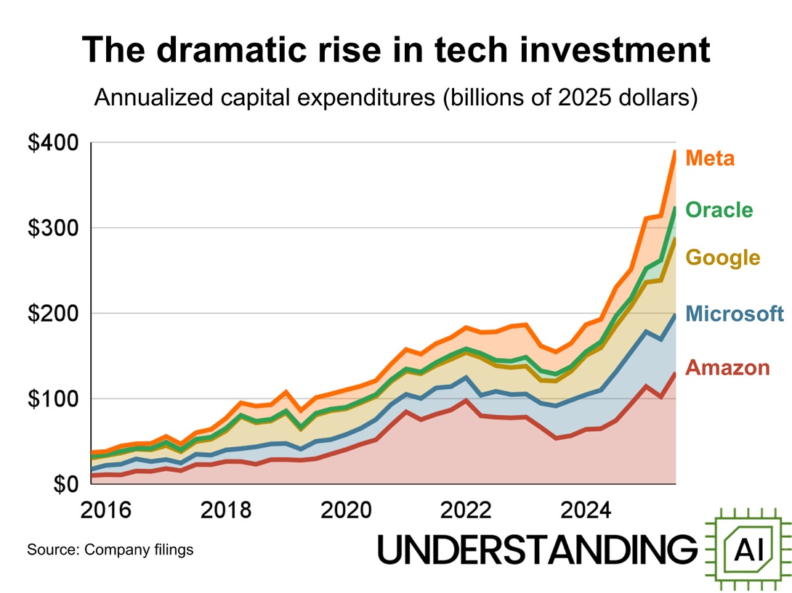
Figure 1 Graph showing the investment into AI by large companies over the last 10 years
Figure 1 (above) describes the investment that large tech-based companies are investing over the last 10 years, with Meta having the largest increase of roughly $350 billion compared to 2016. This shows that many companies are interested in the development of Artificial Intelligence and are willing to put their wallet behind it.

"Artificial intelligence refers to computer systems that can perform complex tasks normally done by human-reasoning, decision making, creating, etc." (NASA, 2024).

What most users are familiar with is more commonly known as a Large Language Model (LLM) (MIT, 2021). This is a model that will learn off humans and how they talk and interact and attempt to replicate it by selecting words that are commonly used in response to the query asked. LLM's are a very basic form of AI as they do not have "intelligence" in the sense of how we as humans would describe and simply guesses at what it should say in responses. Machine Learning models are another form of AI and are primarily used in statistics, numbers and logic - "learning" from generalised sets of data to make predictions on unknowns.

Model Context Protocol (MCP) is an open-source internet protocol aimed at connecting data sources, tools and workflows into an AI model (MCP, N.D.). By using this method in a local Integrated Development Environment (IDE), users will be able to use AI models to complete tasks on their own machine instead of outsourcing the task to an AI server that is negatively impacting the environment.
(MIT, 2025) (UNEP, 2025)

The main issues with AI currently are many, with some being that generative AI (AI models that are able to create visual media and audio) are driving many people out of their jobs – “As Artificial Intelligence (AI) continues to progress and its integration in various industries deepens, worries about job displacement have intensified” (SOUEIDAN, 2024); the environment suffering off the back of the AI expansion with data centres and data farms polluting and destroying habitats (UNEP, 2025) and the cognitive affect that using AI for basic questions and functions is having on us as humans. However, AI does also provide us with many beneficial use cases such as diagnosing cancer and disease before traditional methods and assisting physicists and astronomers with discovering new structures in our universe to name a few cases. (NIHR, 2023) (CERN, 2024) (OXFORD, 2025)

The aim of this project is to understand Artificial Intelligence in its entirety. Looking at the different areas that AI affects such as:
- Environmental aspects
  - Electrical Consumption
  - Water Consumption
  - Local and Large Habitats
- Human aspects
  - Societal
  - Mental
  - Research
  - Living

This project also aims to explore how MCP servers can be used at home or in a business setting. To do this I will attempt to build my own MCP server, using Claude as the AI model and see how easy they are to setup, run and maintain.

Due to time constraints this project changed into a cleaning robot simulation, still allowing me to understand the benefits that local AI could bring, in this case within a confined system that operates on its lonesome with no internet connection.

This cleaning robot needs to be able to:
- Sense the room around itself and map the floorplan, storing this for use during its cycles.
- Be able to return to its charging station when required.
- Be able to vary its fan speed, allowing for more effective cleaning at the expense of power draw or vice versa.
- Be fully self-sufficient, the user should be able to turn the robot on, and it works until the room is clean.
- Be able to take in its surroundings and manoeuvre around obstacles that are not listed within the complete floor plan, for example, on a future cleaning run.

2. Literature Survey

There are many existing papers outlining how AI is useful for our day-to-day tasks but also how it can be a destructive and malicious force to not just our environment but to us as Humans from a cognitive standpoint.

It was difficult to find any sources that were looking at the topic of this paper, with the most comparable articles and papers looking at specific areas Artificial Intelligence was affecting and not attempting to argue the whole picture or looking into how AI would surpass us as a species. With the viewpoint of this paper looking to obtain an understanding of the current state of AI’s effects on the environment and humans, piecing together a broader picture from the many focused topic papers and articles was necessary, allowing me to reach a conclusion about how Artificial Intelligence was currently being used and the effects it was having now and in the immediate future.

Giving this gap in research, this project aims to take these sources and attempt to summarise the various areas in which this new wave of Artificial Intelligence is affecting and will affect in the future. It aims to give the reader a comprehensive view of the world of Artificial Intelligence, such as the environment it affects, the humans it interacts with and the way we as a society should be using AI.

Using sources from different fields and subjects allows for a fuller view of Artificial Intelligence and what it affects. News articles and respected publishing organisations provide a more human, real-world experience of Artificial Intelligence, while needing to be checked against other sources to ensure the validity of the information. Scholarly papers and research organisations provide a more objective view, saying how Artificial Intelligence is affecting certain aspects and giving a detailed analysis of the issue at hand. Combing these sources allowed for an objective yet informed view of AI.

3. Methodology

3.1 Research Question

Given how AI is growing seemingly exponentially as of recent years, I want to explore how useful AI is to us as a species. This includes the typical usages of AI such as Large Language Models; specific uses such as medical or fringe science and the potential drawbacks such as environmental damage and the impact on the human mind.

This further raises questions on how we as a society can manage this new aspect of our lives and how can governments regulate and keep AI to a high standard of build quality and ethics.

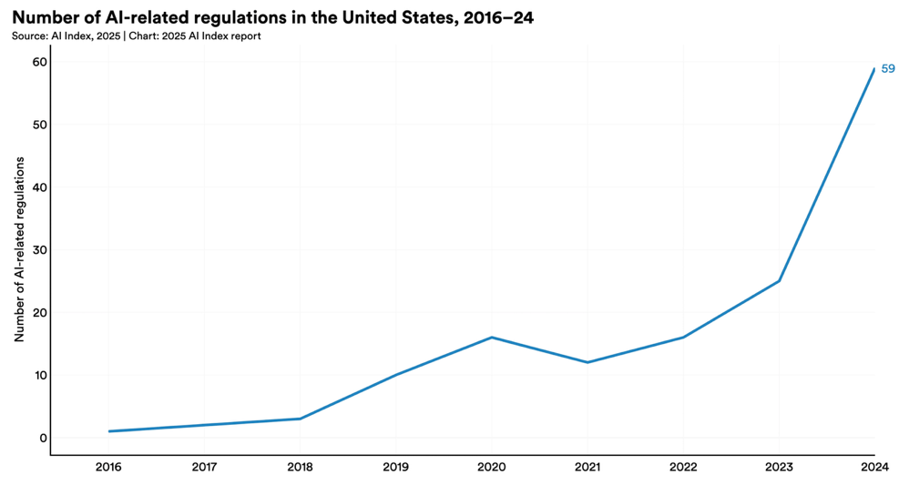
Figure 2 Number of AI regulations in the US 2016-24 (STANFORD, 2025)
Figure 2 (above) represents the rise of AI-related regulations in the United States from 2016 to 2024. The graph clearly shows a rise, aiming to combat the many different areas and issues that the use of Artificial Intelligence brings and provides an insight in to how much more AI was being used in 2024 as opposed to 8 years prior.

3.2 Ethical, Legal, and Professional Issues
Sources/Sourcing Data

I did not need to source data sets as I was not testing nor training an AI model or other such program.
The sources I obtained were through extensive research and ensuring that the credibility of the sources was valid, such as only using sources from established and respected organisations within the field or papers with multiple citations and respected authors. Some examples of the sources I have used and validated are below.

United Nations – Sourcing from the United Nations is a credible way of obtaining information as it is an internationally backed organisation with multiple countries involved in the validation and sourcing of their information.

NIHR – The National Institute of Health and Care Research is an organisation founded in 2006 by the British Government for the primary goal of “[improving] the health and wealth of the nation through research”. The source is credible due to its ties to the British Government and its nature of research with the NHS as a close partner.

MIT – The Massachusetts Institute of Technology is a private research University was founded in 1861 to advance “useful knowledge” and is considered one of the top Universities in the United States. This source is credible for the number of cited papers and results the research from the university has produced.

CERN – The European Organisation for Nuclear Research is a multiple nation effort that aims to explore the limits of particle physics. Based in Geneva, Switzerland, it has many European nations collaborating with the scientific efforts.

NASA – The National Aeronautics and Space Agency is a US government funded organisation with many multi-nation backed missions and research papers that have been peer-reviewed by scientists around the globe and is regarded as one of the leading space agencies.

Legal and Ethical

At no point in this project did I need to create a survey to collect opinions or data points and so I did not need to adhere to any legal restraints with regards to surveys.

“AI-infused technology such as computer vision can enhance public security, for instance by identifying crime in real-time based on CCTV cameras, but the trade-off is that can also be abused to track individuals and to establish a surveillance state where privacy is greatly threatened by those who control the technology” (LUCCIONI, 2019). Artificial Intelligence in its entirety is a morally and ethically grey area. This meant that discussing AI was going to exist in a similar grey space and therefore must be treated with non-bias to exclude opinions. By doing this I am able to look at Artificial Intelligence in a purely objective and logical manner, allowing for a balanced and unbiased outlook into the world of AI.

3.3 Tools & Technologies

I used solely PyCharm to program my software artefact, given that I was coding a basic AI in python and PyCharm is a leading Integrated Development Environment (IDE). This environment allowed me to test, run and build my cleaning robot without the use or need for other tools as my simulation was ran in a command line style.

To obtain my resources I used a combination of Google Scholar to access academic papers and Ecosia (Alternate search engine to Google) to access organisation’s websites for their published articles. By doing this I was able to get a larger understanding of the areas of AI I was researching, tapping into different types of research and publications to give me a bigger scope of the subject.

3.4 Time Management

I aimed to get each section of this project done on a week by week basis, allowing me to get the project done in a timely manner and each section done with enough time for any changes to be made.

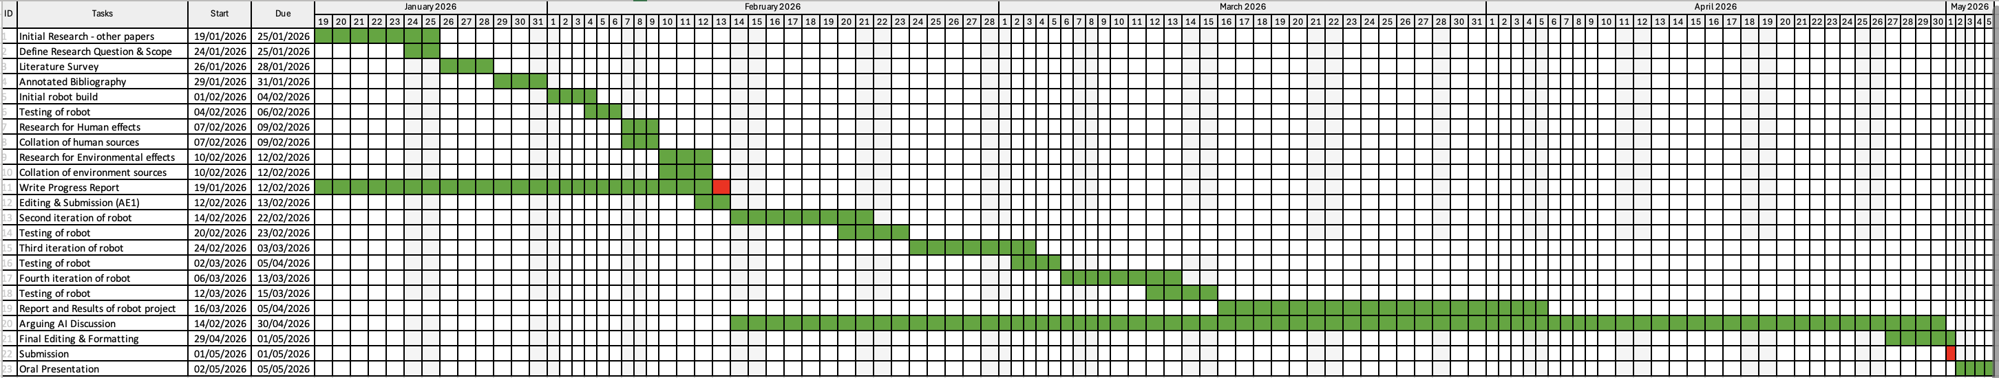
Figure 3 Gantt chart detailing the planning of my project
The project became larger than I originally anticipated due to the task of researching and finding adequate and reliable sources that gave me a neutral outlook onto the effects of Artificial Intelligence in different areas. Because of this unexpected turn in the project, I started my coding project at a later date than I originally planned out in the Gantt chart (Figure 3) above, causing a delay in the subsequent tasks and therefore not completing them on time in line with the original plan.

Attention Deficit Hyperactivity Disorder (ADHD) also inhibited my time keeping skills within this project despite it being something I actively enjoyed. ADHD effects executive function and motivation levels (LOPEZ-VERGARA, 2013) and these effects were very present during my time undertaking this project. Due to this I struggled with keeping to the Gantt chart and completing the laid-out tasks on time, compounding the issue of the already growing project. I ended up completing the majority of the tasks near the end of March and through April, instead of the early February into March originally planned

For my coding project I aimed to initially explore the uses of a Model Context Protocol server. This allows for a user to download and run an AI model on their local machine, allowing for a more environmentally friendly way of using these new tools, instead of outsourcing the work to a data centre which further perpetuates the problem. I struggled with the time management of this project and so opted for a more scaled down but still equally informative project instead – a simulation of a cleaning robot using a basic form of AI. This allowed me to show that an AI onboard a system can function without network connection and no outsourcing of processing power. Although this is a basic system and for it to work on an actual fully-fledged cleaning robot it would need a lot more complicated functions, the premise for it is sound and allows for me to explore this area of AI.

4. Design & Implementation

Designing the cleaning robot simulation involved the creation of a basic AI, one that was provided information through the floor plan and the onboard data of the robot and would make decisions based off of these parameters.

The initial design entailed an extremely basic model in which the Roomba will choose a direction to follow until it hit a wall, changing its direction and continuing or until its battery depleted. The robot would not clean a “tile” (Defined by breaking the floorplan up into a grid) and would only charge by 5 points if the robot passed in front of the charging station, with the charging station acting independently – charging the robot regardless of its decisions. This is to test that the basic functions of each system work correctly, such as the movement of the cleaning robot and the charging functionality of the station.

The next version added complexity into the robot’s decision cycles, with the cleaning robot gaining some basic intelligence and can decide which tile to prioritise based on the weighting of the tile. This weight is defined by a value of 0-100, arbitrarily decided at the start of the simulation and shows the “dirtiness” of a tile.

Before each cycle the robot will carry out a pathfinding check to see how many moves, turns included, it will take to return to its charging station before its battery runs out from the robot’s current position. The robot compares this number of moves and turns against the charge of the battery. If the level of the battery is equal to the number of moves and turns it takes to return to the charging station plus an additional move for redundancy, the robot will take this option to return to replenish it’s battery. If the number is lower than the current battery level then the robot will continue to clean the tile, with this check being performed at the start of each cycle.

The robot will then look at the adjacent tiles and use one cycle to move toward the largest value if it is directly in front, or the robot will store the location of the tile and use as many cycles as it needs to turn toward the largest value and then another cycle to move onto the tile. The robot will then use as many cycles as it requires to clean the tile, reducing the value of the tile each cycle by 1.

At this stage the program is capped at 200 cycles to avoid the program running infinitely and allowing for me to gain a good idea of how the program functions, checking for any errors in moves or choices that the robot makes.

Once the main cleaning functions were created, I designed the full return function utilising a Manhattan Distance function, allowing the robot to observe how far it is from the charging station its current location is, this is the same function that is detailed above that enables the logic for returning or to remain cleaning. Once the path has been calculated and the choice for returning has been made the robot will return back to the charging station. Once reached, the charging station will detect the robot on the tile directly in front of it and use a cycle to charge by 5 points. When the robot is fully charged the charging station will allow the robot to return to the tile it was cleaning previously.

Below is a diagram I created to help visualise the choices that the entire system would make. By doing this it became much clearer the direction I would need to go about programming the functions. By doing this in order of the decisions laid out in the diagram I was able to test each individual aspect as I was building the functions, allowing for me to ensure that every function was working effectively and correctly before moving onto the next section of the flow chart.
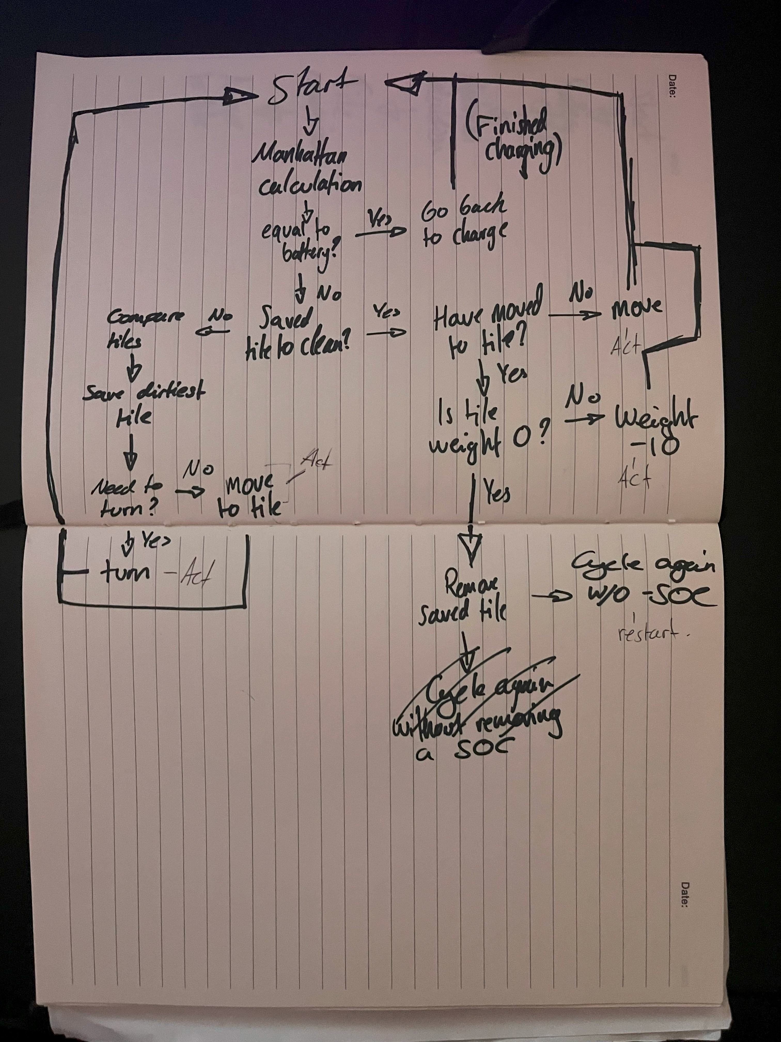
Figure 4 Diagram of cleaning robot choice flow chart

The next iteration of the cleaning robot began with a simple idea, the addition to the system would be a new cleaning function that contained fuzzy inference systems. “a fuzzy inference system (FIS) is a popular computational scheme based on the concepts of fuzzy set theory, IF-THEN fuzzy rules, and fuzzy reasoning.” (REYES-GARCIA, 2022). The new version of the robot would include fuzzy logic to define certain aspects of the cleaning robot, this would allow the robot to vary its fan speed, battery drain and the rate of cleaning.

The robot first infers the fan speed. It does this by taking the battery level and the tile ‘dirtiness’ (0-100 as before) and runs these values through the first fuzzy inference simulation. The simulation decides how fast to spin the fans via this function, if the tile is ‘filthy’ and the battery level is ‘high’, for example, then the robot decides to spin the fan at a high speed.

The robot will then calculate the battery depletion rate and the cleaning speed from this fan speed. Using fuzzy logic once again the rules decided for the battery depletion are:
• If fan speed is low, then battery drainage is low
• If fan speed is medium, then battery drainage is medium
• If fan speed is high, then battery drainage is high

For the rate of cleaning:
• If fan speed is low, then cleaning rate is low
• If fan speed is medium, then cleaning rate is medium
• If fan speed is high, then cleaning rate is high

By changing the cleaning function from the previous function into this new fuzzy inference model, the robot is able to vary its fan speed, in turn varying the cleaning rate and battery depletion and increasing the efficiency of the robot overall. For each cycle these fuzzy inference simulations are ran, decreasing the battery level and the tile dirtiness each cycle, with the Manhattan Distance function being ran before the fuzzy functions are called upon with a change to the redundancy value, ensuring that the distance to the charging station plus the max battery depletion value is equal to the current battery level.

I housed each of the fuzzy simulations into their own subfunctions for visual clarity within the program, making it easier to test and observe which function relates to which part of the overall fuzzy inference system. The cleaning function worked as expected apart from ‘sim 1’, the simulation that calculated the fan speed of the robot for the subsequent functions to use would throw ‘KeyErrors’ seemingly at random. I could not resolve this issue in time.

The membership values for each of these functions are completely arbitrary. I chose them in relation to what I would view as ‘dirty’, ‘bearable’ and ‘clean’. I started by mapping this logic into the dirtiness levels and using these same values for the fan speed fuzzy inference. My reasoning behind this is that the fan speed should correspond to the dirtiness of a tile, in a 0-100 scale for both factors they should match. This can be demonstrated by the example in figure 5 (below).

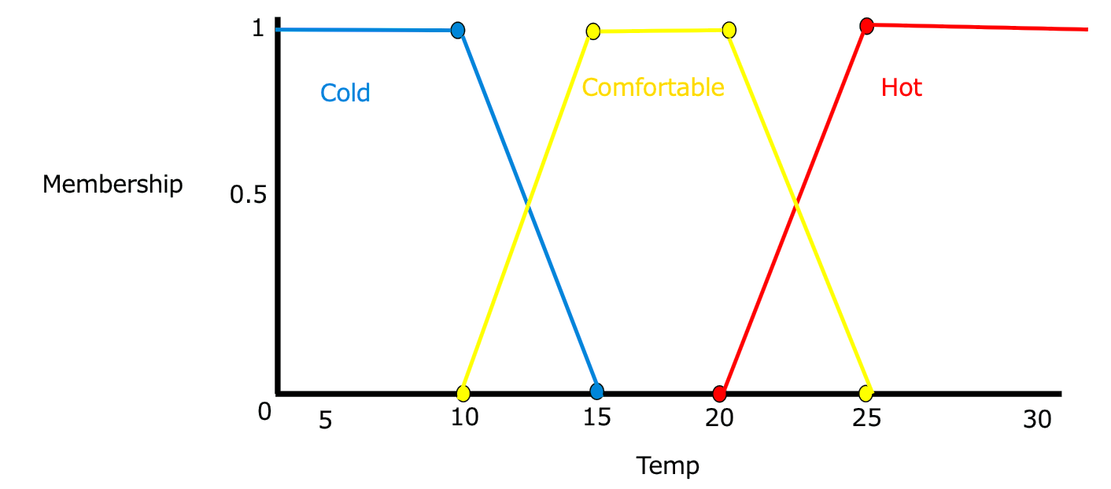
Figure 5 Fuzzy Logic Diagram showing the membership values at different temperatures (SOLENT, 2024)

Once these values were set, I moved onto mapping the battery level with the membership values being based upon how I viewed my phone battery, using the idea of when I would worry about beginning to charge it, when I would be cautious about the level and when I knew I had a decent amount of charge. The battery drainage rates and cleaning rates were quite similar to each other, they both use similar ‘step’ values with each low, medium and high ‘fuzziness’ for the memberships. The cleaning rate is nearly double the battery drainage for each value, with some differences due to the arbitrary scales.

I would have liked to incorporate a full machine learning model for the cleaning robot; however, I did not have the time to complete this. If I had more time available for the coding, I would have liked to have completed this as a method of fully exploring the use of Artificial Intelligence within local systems.

Testing each of these iterations of the project was imperative to ensure that I was then able to build onto the next. The testing process involved leaving “markers”, print statements that showed the current “thought process” of the program as it was running. This allowed me to see what sections were being reached successfully and what sections were tripping, not completing and therefore halting the program.

5. Arguing AI
The growing AI bubble requires more data centres to be built every day, and these centres needing to be ran 24/7. This means that water and electrical usage will skyrocket per centre built, decreasing availability of these resources for nearby towns and communities who have the share the infrastructure with these buildings. According to the (IEA, N.D.), "[the] average AI data centre has an electrical footprint equivalent to 100,000 households", with larger centres that are currently being constructed forecasted to consume up to 20 times as much as operational data centres running today. This is an incredibly large amount of energy that could be put to good use in other areas instead of reducing availability for households.

Let’s look at what a data centre actually is, what the ins and outs of such a building are and why building more of them can lead to issues all over the planet.

Modern data centre architecture is typically virtualised, meaning that a physical component such as a Central Processing Unit (CPU) or Graphics Processing Unit (GPU) can be running multiple instances of a computer allowing for compartmentalisation of each virtual system to a specific core on one CPU, or spread across a pool of physical components that allow greater processing power than a “typical” system would allow (IBM, N.D.). By using virtualisation, companies are able to constrict certain workloads to optimise performance across the system as a whole without altering any of the actual physical parts within the data centre.

To make an entire data centre there are many individual components and systems that allow it to function as a whole. Servers within the data centre come in many different forms:
- Rack mounted servers – These are wide, flat stand-along servers that are stacked vertically to save floor space. Each “rack” has its own power-supply, network capabilities, cooling systems, processors, memory and storage. This allows for multiple fully capable systems in a small area.
- Blade servers – Designed to save even more space, each “blade” contains processors, network capabilities memory, with storage not being a necessity but can still be fit. The blades are made to fit into a frame that holds multiple blades with a single power supply across them and other shared resources.
- Mainframes – high performance computers that can do the workload of a whole room of rack or blade servers. Mainframes were the first computers made to be virtualisable and can process billions of calculations and network transactions in real time.
(IBM, N.D.)

Environmental controls within a data centre are critical. They keep the functionality of the components optimised and healthy by mitigating fire risk, keeping everything cooled, keeping the humidity low and ensuring static electricity is discharged safely.

Temperature control is typically done by a combination of water and air cooling to keep the hardware within the centre at an optimum temperature range. This is where the majority of the building’s water consumption is used and once used within the heat exchange process is typically discharged back into the environment whether as warm liquid or hot steam. This in turn warms the surrounding environment and altering the balance of the ecosystem, in time causing local climate change. The average data centre consumes 5 million gallons or just under 23 million litres of water per day, a level equivalent to a town populated by 10-50 thousand people (EESI, 2025) The water consumed within the “cycle” of cooling typically refers to water that evaporates or is taken out of immediate human usage, meaning that freshwater from local sources (rivers or aquifers) are no longer available for households to use. Consistent water consumption from these data centres, particularly in water stressed areas, can lead to source exhaustion and cause local droughts.

Human Impact
The impact on humans that AI can bring can be broken down in multiple sections: Societal, Mental, Research and Living. Societal impact explores how AI will affect human lives on a relational standpoint, looking into how our relationships with others are affected by the usage of AI. Mental impact explores how the usage and advertisement of AI impact our mental health, whether it is positively or negatively impacting our own brains. I have included research in the human impact as utilising AI in fringe sciences has the potential to help scientists find new important discoveries that can directly benefit our day to day lives and help us to progress as a species. Finally, living has been included as a combination of all the above. It looks to explore how our living conditions are impacted by AI, whether this be the direct impact it has on a user or the indirect impact it has via environmental factors and constant advertisement to nonusers.

Societal
Our relationships as humans have many factors that define them. Adding AI into the mix is something no one has had to deal with before and so not many can predict accurately how our friendships with each other will be affected.

With LLMs such as ChatGPT or Claude acting as a third-party opinion for some, incorporating this into their relationships could be potentially detrimental. Letting these LLMs into a person’s thought processes on a daily basis could effect the decision making when adding in another person, say a partner or friend, could make this process significantly slower with the possibility of creating arguments between the two.

Human emotional relationships are further being affected by AI with chatbots on the rise. Many companies are offering “digital friends” for humans to interact with. “Character.AI has 20 million monthly users, and more than half of them are under the age of 24. It’s been a norm for a while for Replika users to ‘marry’ their AI companion in virtual weddings to which they invite friends and colleagues…” (APA, 2026).

According to the American Psychological Association digital companions purposely being built to provoke responses in humans that anthropomorphise these chat bots, causing the humans that interact with these “companions” to form real connections with them. Many platforms offer ways of customising these bots too, further developing the connection with the human user as they a character they wish to see and talk to. These bots are specifically designed with the intention of provoking specific responses in humans, highlighting an exploit and within the human conscience that is not being dealt with by either government or company (APA, 2026). An oversight that seemingly is there for the sole purpose of turning a profit for these companies with little to no care for the actual user at the other end.

On the flipside however, these AI chatbots can help humans who are struggling with social aspects such as talking or interacting with people, whether this is a nervous aspect or a condition they have dealt with before. They give the user the space and conditions to practice these interactions in a relatively safe environment, allowing the user to attempt social interaction in a non-overwhelming way with guardrails. A study by Julian de Freitas et al reported that they identified “feeling heard” and messages being received with attention, empathy and respect as the main reasons for why AI companions are perceived as effective in reducing loneliness.

This perceived reduction in loneliness can help some of the more affected members of society gain the confidence they need to try and reconnect with others and regain meaningful relationships in a healthy manner.

Mental
The effects that artificial intelligence can have on our mental health are potentially limitless due to how many different ways it is being used. On one hand, it allows a way of diagnosing conditions in ways a human could not and provides a way of afflicted individuals to talk about their conditions in a safe and healthy way without a human present (ETTMAN, 2023). On the other, it presents a larger issue with the use of generative artificial intelligence and the over-reliance on these resources.

“Randomised controlled trials have found that students performed better when using general-purpose generative AI tools but performed worse when these tools were taken away” (CHEN, 2025). This trial shows that when students use AI for their studies, if they are unable to use artificial intelligence for the same task, they perform worse in comparison. Youjien Chen suggests that this use of AI shows that students may be relying on AI to bypass cognitive process essential for developing their cognitive skills, leading to a student who performs worse on their own than if they weren’t a user of AI.

When adding this in with the societal effects, we can begin to see that humans who are relying on artificial intelligence could struggle with daily life. The reliance on AI to undertake the cognitive functions of the human brain could cripple their ability to make decisions and to function in a healthy way, potentially leading them to interact less with humans and more with AI on a day-to-day basis. This, in turn, causes a lonelier way of living and, dependant on the person, a lower mental state. This lower mental state could restart this AI-dependant cycle and further cement the person into this way of life.

“A subsequent study has found that generative AI boosted learning for those who use it to engage in deep conversations and explanations but hampered learning for those who sought direct answers” (CHEN, 2025). This study suggests that when used the correct way generative artificial intelligence can act as a tool or resource, much like a lecturer or search engine, allowing the user to bounce ideas back and forth, engaging their brain in manner that allows for growth and learning. This shows that AI has use within the field of learning, but we must be able to differentiate between healthy use and detrimental use on the person’s progression. By teaching this at an early age we can enable the next generation to be able to correctly and effectively use AI as a tool for research and curiosity instead of a potential mental health black hole, in which one would become reliant on the AI for answers and guidance.

The use artificial intelligence within the field of diagnosing and managing mental health conditions could be beneficial for individuals suffering with their conditions. With over 970 million people worldwide living with a mental health condition, the use of AI could influence our mental health via prevention and effective treatment (ETTMAN, 2023). Artificial intelligence can enable us to help the most vulnerable quicker, by identifying higher risk populations to prevent severe mental illnesses and lead to quicker intervention. “AI can detect, assess, and predict stress. For example, AI can process natural language from electronic health records to detect early cognitive impairment or child maltreatment” (ETTMAN, 2023), this presents an opportunity for medical officials to use AI within the diagnosing process as an assistive tool to speed up processes and allow for more patients to be treated effectively with a high level of care.

Artificial intelligence still poses some risk within this sector however, including some biases from its training that could lead to stereotypes being perpetuated and assessments being inaccurate. With the potential for AI to deliver mental health support and assessments, such as specially designed chatbots, we are yet to well understand the long-term effects of this shift. Is replacing human compassion, experience and more importantly judgement with a programmed intelligence as beneficial as some think it could be? How accurately can an artificial intelligence model mimic these specialists in their respective fields and effectively treat patients to the same level of care, if not further?

Research
Astronomers and Physicists are already using artificial intelligence as a tool to help with their research of the unknowns. Particle physicists at the European Organisation for Nuclear Research (CERN) in Geneva have been using AI to help them find new signs of undiscovered particles, building blocks of our universe. The Large Hadron Collider, a 27km long particle accelerator, deals with billions of collisions of particles and exploring this data on a human level, even with specialised programs built by the scientists, is a huge task to undertake. Instead of this, during some experiments the detectors ATLAS and CMS (Compact Muon Solenoid) are using AI to sift through this data for them. (CERN, 2024)

“By studying the shape of their complex energy signatures, scientists can determine what particle created the jet. Using real collision data, physicists at both experiments are training their AI to recognise the characteristics of jets originating from known particles.” (CERN, 2024). Training their models on previous collisions and results allows them to create a AI that accurately and precisely identifies particles present in the collisions, and by feeding the Standard Particle Model into these AI’s they can detect particles previously undetected by extrapolating on the data received from the detectors, previous collisions and the particle model inserted. The models are trained on “jets”, particle signifiers, that leave the original collision and hit a detector wall. When combing through these jets the AI looks for typical signatures, particles it has been trained on and has seen before, if an atypical jet is found this is usually a tell for a new particle being discovered. (CERN, 2024)

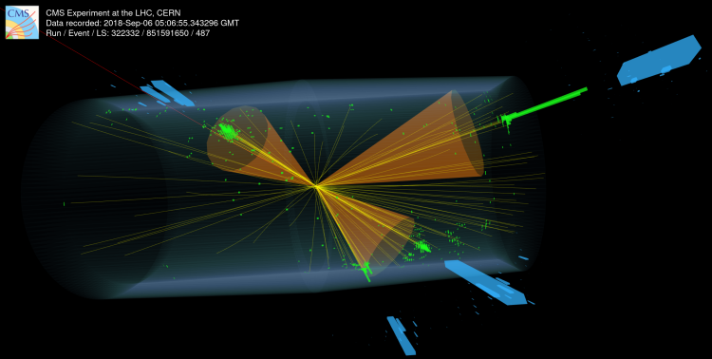
Figure 6 Event display of one of the CMS events determined by the AI algorithm to be highly anomalous and therefore potentially coming from a new particle. (Image: CMS collaboration) (CERN, 2024)
This shows that AI has a large role in the research and discoveries within particle physics, proving it can be of use to scientists within this field.

During the Covid pandemic in 2020, an AI model called AlphaFold was being used to attempt to virtually fold proteins to help understand their uses in viral research. This was being carried out to find vaccines by better understanding how viruses function.

“Proteins play a crucial role both in building biological structures and in managing biochemical processes in living organisms.” (GUTNIK, 2023).

By folding proteins and gaining a 3D render of them, scientists can understand how they function with regards to other crucial biological molecules. Doing this process “by hand” takes an extremely long time and so DeepMind set out to outsource this task to a sufficiently powerful, accurate and precise AI model. “AlphaFold-Multimer was benchmarked on a large dataset of 4446 protein complexes, successfully predicting the interface in 70% of cases of heteromeric interfaces and in 72% of cases of homomeric interfaces. A high level of predictive accuracy was demonstrated in 26% of cases of heteromeric interfaces and 36% of cases of homomeric interfaces.” (GUTNIK, 2023). This level of accuracy in predicting protein structures allows for scientists to use the AI alongside human study in many different fields, especially virology given how it was successfully utilised during the 2020 pandemic.

Living

The living standards of humans after the large-scale introduction of AI during recent years has and will vary, from an environmental, mental and societal perspective. With the sheer consumption of fresh water that AI data centres undergo, the surrounding areas suffer from water shortage or water contamination severely affecting the people residing in these areas near the data centres.

For example, in Georgia, USA Beverly Morris lives 366m away from a Meta-owned data centre. “’I can't live in my home with half of my home functioning and no water,’ Ms Morris says. "I can't drink the water.’” (BBC, 2025). The construction of the data centre is believed to have disrupted the ground water in the surrounding area, causing this drop in water quality and availability.

Living standards around data centres, with regards to water supply, are thought to be dropping with AI data centres predicted to consume 1.7 trillion gallons, or over 6.4 trillion litres, of water globally per year. This extreme water usage constricts water sources and drives down the availability for other users, such as households, small businesses and more importantly the surrounding natural environment (BBC, 2025).

Unemployment is a big potential for AI, with jobs such as car assembly lines being replaced with robots and machines powered by simple AI. Even other aspects of our lives like supermarkets have the potential to replace their workers with AI driven robots and check-outs (Cheng-Tek Tai, 2020). This shift in our current way of life can affect many members of society, if their position is deemed unnecessary as an AI can undertake it, they’re likely to get axed from that position.

Higher-ups in companies seem to tend to focus on profit first models, especially with the new AI boom recently, leading them in this case to focus on minimising their production costs. A human worker is hard to control and figure out and is a potential risk with them being able to become ill suddenly or have other priorities in their life. An AI controlling multiple robots and machines is effective and efficient, with the main liabilities being the program and physical machines. Both of these potential liabilities are easier to manage with respect to a human counterpart, as they only require routine maintenance (something an AI can log and manage, calling in necessary support as needed) and updating when necessary.

Comparing this to a human who needs breaks to manage energy, isn’t always 100% reliable and has a mind of their own AI-ran machines seem to be the more viable choice. However, if companies are to go down this road of replacing people with artificial intelligence, other paths for these redundancies need to be made, allowing these workers to keep operating either within their company or given the right chances and pathways to find another career that suits that worker, or for the workers to be allowed higher positions managing these AI machines and becoming supervisors of the assembly lines. This allows for the people to potentially still have a say in what happens within the AI scene, not leaving it all up to the CEO’s and corporate boards who aren’t necessarily that in tune with the average person.

Environmental Impact
Similarly to the impacts on humans, the impact on the environment can be broken up into 4 main points. These points are electrical consumption, water consumption, the emissions the use of AI releases and the effect on habitats surrounding data centres and other infrastructure due to AI.

“The environmental impact of AI is becoming harder to ignore, from soaring energy use and water consumption to the rapid expansion of data centres and microchip production. What is being built in the name of innovation is also concentrating power, intensifying surveillance and deepening democratic risk.” (GREENPEACE, 2026)

It is ever more important that we are aware of the impact that we have on the environment and its inhabitants, and with the rise of AI we need to be increasingly more vigilant of the direction we are taking with AI and how we are going about it. This is a task that everyone needs to be a part of, with the large organisations creating and pushing for more artificial intelligence integration and usage constantly checking themselves with their policies and methods and the general population calling out and keeping on top of these organisations when they fail. If we are not careful of the impact that the rise of artificial intelligence could bring to our planet, there could be major consequences for all – potentially to the point where the societal impacts previously mentioned are worsened or not important compared to the environmental issues we could face.

Electrical consumption
“Electricity demand from data centres soared by 17% in 2025, and that of AI-focused data centres climbed even faster – well outpacing growth in global electricity demand of 3%” (IEA, 2026), the consumption of AI-centred infrastructure skyrocketing shows us that the use of this new resource is likely unsustainable with the possibility of even being unstable. If AI is taking increasingly larger percentages of the energy grid, either homes and small business will be driven out of electrical availability, or the overuse of the energy grid will cause it overload and short out. This will leave not only the data centres without power but the rest of that section of the grid with the possibility of much wider blackouts if the usage and damage is extreme enough.

According to the International Energy Agency, the energy consumption per individual AI task is dropping, with the efficiency in the programming and physical components increasing. However, the ever-growing number of users is causing an increase in the electrical consumption overall, counteracting this rise in efficiency. Due to the increase in users the electrical consumption from general data centres is set to double by 2030 and AI focused centres’ consumption is set to triple in the same period.

This presents a huge issue for power companies as they will be providers for this dramatic increase. These companies should focus on moving to renewables or nuclear as a cleaner way of generating energy if they are to enable the extreme consumption, or we as a people should be pushing for the use of renewable energies or small nuclear setups on the site of these data centres, allowing them to be self-sufficient with no external strain on the outside grid. With this renewable option in mind, if the companies opted for this route, they would be able to sell excess energy production into the main grid, allowing for another method of income.

The IEA reports that “[AI] accounted for around 40% of all corporate power purchase agreements for renewables signed in 2025 and is also now a major source of momentum for the nuclear and advanced geothermal industries.”, showing the AI industry’s potential to help innovate new energy technologies and further boost current, clean energy methods. The requirements of AI centres could help accelerate some experimental energy sources into commercialised methods, such as Small Modular Reactors (SMR) whose output has increased from 25 gigawatts to AI focused data centres in 2024 up to 45 gigawatts today. This large of an increase could indicate a viable future for the technology within the world of data centres and potentially in a wider scope, with use cases like hospitals and other key infrastructure in which power is a necessity 24/7.

Water consumption
“Data centres have a thirst for water, and their rapid expansion threatens freshwater supplies. Only 3% of Earth’s water is freshwater, and only 0.5% of all water is accessible and safe for human consumption” (EESI, 2025). This alone proves that with freshwater’s scarcity there should be some form of legislation limiting how much water a data centre is allowed to use in a specific time frame.

By doing this it would allow for a much more manageable consumption rate and allow for water sources to remain available for all without being stretched thin by the overuse in AI cooling systems. It seems with some companies like Meta, data centre cooling systems take priority over their local neighbour’s access to safe, clean drinking water. As discussed previously Beverly Morris does not have this clean water access due to living so close to a Meta-owned data centre leading to her having to use water that is filled with sediment runoff and other water pollutants tell-tale of nearby construction work (BBC, 2025).

Making data centres more water efficient than they are currently or moving them away from the usage of water cooling completely would help to mitigate this mammoth issue of water consumption. The Environmental and Energy Study Institute outlines multiple ways of reducing a centres water consumption:

- Closed loop cooling systems – Enables the reuse of wastewater in combination with fresh water, reducing the strain on the fresh source and allowing for the water to be used in multiple cooling cycles. A cooling tower can be used in tandem with this method to cool the cycled water. This reduces the use of freshwater by up to 70%.
- Free cooling - Outside cold air is drawn into the centre to cool the equipment, reducing energy costs due to the semi-passive nature of the cooling. However, this method is only effective if the data centre is located within a cooler environment.
- Air cooling – Uses vents and fans to push air over components to cool them down. This method is more effective where energy costs are lower, and water availability is scarcer than others.
- Immersion cooling – A process that involves bathing server components in a dielectric fluid – a liquid that has no conductive properties. The components are stored within a tank of the fluid, in which they are cooled with the dielectric fluid then transferring the excess heat out of the system via a heat exchanger. This cools down the fluid before it re-enters the tank. Immersion cooling offers a massive energy savings compared to active cooling processes and allows for more compact, optimised spaces. It does require higher upfront costs to build than conventional cooling systems but the benefits it offers are significant, making it a worthwhile investment from an environmentally friendly and energy saving point of view. Since the process uses synthetic fluids – created by humans – significantly less water will be used in the process compared to other methods, allowing for a more sustainable method of cooling and affecting the surrounding environment not nearly as much.

“With approximately 56% of the electricity used to power data centres nationwide coming from fossil fuels, deploying more clean energy to power these facilities can significantly reduce water consumption.” (EESI, 2025). Coal power plants use approximately 19,815 gallons, or over 72,000 litres of water per Megawatt Hour (MWh) and natural gas using roughly 2,800 gallons, or over 10,000 litres of water per MWh. This compounds the amount of water that a data centre consumes, even if indirectly. The sheer volume of water used for cooling in a data centre and the volume used for generating the power for the centre is immense.

“In 2022, 40% of all total U.S. annual water withdrawals, or about 48.5 trillion gallons, were made by coal and gas power plants. Of those 48.5 trillion gallons, 962 billion gallons of water were consumed and were no longer available for direct downstream use.” (EESI, 2025). Solar and wind-based methods of power generation don’t use water in their processes, by converting to these sources alongside the immersion cooling a high percentage of water can be prevented from being used within the cycle of running an AI model, allowing for a much more sustainable and community friendly method of running a data centre.

Habitats
Data centres require land, as any building project does, for construction and operation. Depending on where the data centre is built it can have a significant impact on the surrounding environment or not affect it at all.
Take the data centre in Georgia for example. The construction of this data centre led to the contamination of freshwater sources in the surrounding area (BBC, 2025). Not only does this affect the humans living nearby, but it would drastically affect the flora and fauna existing around the centre. Having a contaminated source of water could push species away from the area, forcing them to look for a new source. This has the potential to push the ecosystem’s balance out of order, with certain groups’ populations now growing out of hand and with others potentially declining with no foreseeable bounce back. This is a direct effect from the construction of the data centre, with operational effects having the potential to further push the balance by reducing further the water availability of the surrounding area.

An indirect effect of data centres is the emissions by the power companies they import their electricity from. By burning fossil fuels, these power plants emit greenhouse gasses and other pollutants into the surrounding environment, whether that be gases into the air or contaminated water and other chemicals from runoff or leaks into the ground.

A way for data centres to mitigate the initial environmental damage they have the potential to cause is for them to engage in habitat friendly actions. Ramboll, a sustainability focused architecture, engineering and consultancy company suggests the following points to help minimise the effect that data centres have on their environment from conception to operation.

- Preservation of Natural Habitats: Data centres can minimise their impact on biodiversity by prioritising the preservation of existing natural habitats. This can involve conducting thorough environmental impact assessments before selecting a site for construction. By choosing locations that have minimal ecological value or are already disturbed, data centres can avoid encroaching on critical habitats and minimise the displacement or destruction of species.
- Biodiversity Offsetting: In cases where data centres are unable to avoid impacting natural habitats, biodiversity offsetting can be considered. Biodiversity offsetting involves compensating for the ecological damage caused by implementing conservation measures elsewhere. For example, data centres can invest in habitat restoration projects or fund the protection of vulnerable ecosystems to offset the loss of biodiversity resulting from their operations.
- Sustainable Site Design: To minimise the land footprint of data centres, sustainable site design principles should be adopted. This includes optimising the use of available land by constructing vertically rather than horizontally, utilising compact equipment layouts, and implementing efficient infrastructure designs. By reducing the physical space required for a data centre, more land can be preserved for conservation purposes.
- Green Infrastructure: Data centres can integrate green infrastructure into their site design to support biodiversity. This can involve creating green spaces, such as gardens or green roofs, that provide habitat for native plants, insects, and birds. By incorporating native vegetation, data centres can contribute to the restoration of local ecosystems and provide corridors for wildlife movement.
- Collaboration with Conservation Organisations: Data centres can collaborate with local conservation organisations and environmental experts to develop land management plans that prioritise biodiversity conservation. These partnerships can help identify areas of high ecological value and implement measures to protect and restore them. Engaging in dialogue with relevant stakeholders can lead to innovative solutions that balance the needs of data centre development with the conservation of biodiversity.
- Monitoring and Research: Continuous monitoring and research are essential to understand the long-term impacts of data centre operations on biodiversity. By monitoring species diversity, habitat quality, and ecosystem health, data centres can identify potential issues and implement adaptive management strategies to mitigate negative impacts. This can involve conducting regular biodiversity assessments, collaborating with scientific institutions, and sharing data to contribute to broader research efforts.

By using these points outlined by Ramboll data centre companies can change their way of operation and construction of these centres to be better aligned with the environment, aiming to coexist with the surrounding flora and fauna instead of inadvertently dominating them.

Cloud vs Local AI

Running Artificial intelligence models locally, meaning on the users own hardware is a significantly better option for the environment. By using their own processing power, the user skips data centres all together, allowing for a much more streamlined, personal and environmentally friendly use of AI.

Outsourcing the AI workload to a cloud based artificial intelligence for the reasons discussed above significantly impacts the environment immediately surrounding the data centre leading to a better and healthier environment than that of if a data centre was used instead. If every user of AI was to take this approach as opposed to using an AI model ran by a data centre the effect on the environment would be non-existent, the need for these AI specific data centres being built would also be non-existent allowing for healthy environments and habitats in place of where the building would exist.

Practical Benefits

Running Artificial Intelligence on local systems provide practical benefits to the user. BVM, a Southampton based technology firm details that running AI locally can allow for decreased response times for queries, allowing for faster processing times “making it ideal for time-sensitive applications like machine vision and automation.”

Running Artificial Intelligence locally also allows for better data privacy and security as the system is managed in-house with no external factors. Having a higher level of security is optimal for business and users who are dealing with sensitive information when processing certain queries and running specific tasks, allowing them to complete their processes with better peace of mind as the sensitive information remains within the on-site system. Alongside better data privacy and security comes increased reliability and redundancy from the platform used. This is due to the user being able to monitor and perform maintenance themselves on the hardware they have chosen to operate from, in turn allowing for a quicker response to outages and being able to perform the necessary tasks to return the platform back to operation.

The system, if setup correctly would even be able to function without an internet connection, operating just within the local network, further increasing the level of security and reliability of the system. Redundancy is also a key feature within this system that parallels reliability. If set up in a certain way, multiple instances of the AI model can be run on two or more sets of systems, allowing for more operations done per cycle and for any data produced to be stored across these systems. By building, maintaining and operating the system onsite the user can ensure the data they use and produce with the AI models are secure, with a high level of privacy and with multiple instances of the data stored across multiple storage pools (IBM, 2025), (BVM,2026).

6. Results

The outcome of the program undeniably shows that a cleaning robot can discover a room and save the “map” onboard the robot for future use and can operate without an external input, in the sense of an internet connection and externally ran AI. This is still an extremely basic idea and does not fully test what I would like to, but the concept and premise is still valid into what I am researching.

The performance of the simulation was adequate. It allowed me to explore the uses and implications of an onboard or local AI model and despite having some hiccups with the random errors it worked as expected and enabled the local research.

Limitations of the model were larger than I initially had hoped, given it didn’t test the full scope that I originally set out. I didn’t manage to code the machine learning aspect into the robot and therefore was not able to test this aspect of Artificial Intelligence. I would have liked to have completed this section given more time to fully test this area, providing me with even more information about the uses of AI in this and similar scenarios.

In future I would like to test how Model Context Protocol servers would be of use to us and how easy it would be to set one up for an individual. This would allow me to test the viability of hosting a local AI that I have control and customisability over, instead of outsourcing the tasks to a company owned Data Centre. If the MCP servers are viable, then it would be in the interest of the public to learn and create their own servers to assist them with their queries and tasks.

7. Conclusions

To summarise, Artificial Intelligence is grey area. It has its benefits in regard to helping in need individuals struggling with the workings of society, helping them gain the confidence they need to survive and interact with other members of their community. It also has the potential to help researchers and medical staff to diagnose and detect conditions that previously took time and resources in a much quicker fashion, allowing for better standards of care and faster treatment times. It can help physicists and astronomers probe the edges of the universe for undiscovered particles and undetected structures waiting to be observed.

However, with the way that AI is being used and the buildings that contain it being built, Artificial Intelligence is an inherently destructive and malicious force. It enables the destruction of local habitats and ecosystems surrounding the data centres that run the AI, pollutes the water sources with contaminants and creates shortages in the neighbouring communities. It perpetuates the fossil fuel issue with companies importing power from companies that use coal and natural gas plants, further contaminating and destroying environments.

The impact that AI has on society should not be overlooked either, with the mental toll that talking to chat bots provides being detrimental to the human mind, reducing intelligence and cognitive capacity in students when exposed long-term to AI agents such as ChatGPT.

After undergoing this research project, my overall view of AI is that it is a tool that should be used wisely and carefully. We should be extremely cautious in how we look to integrate AI into our daily lives and with how we aim to operate this new resource. With companies evermore pushing AI upon us in almost every aspect of our lives, we should start to push back against them, boycotting the services that put the environment and our mental health at risk.

Artificial Intelligence is of use to us, but not in the way it is currently being developed and rolled out. With greater care we will be able to provide a safe and sustainable method of utilising the full potential of AI, enabling a new way to better our society and surrounding environment.

8. Recommendations

Given more time, I would like to have researched the possibilities of a Model Context Protocol server and the benefits that it could bring to users. I would dedicate a section of this report to the benefits that an MCP server could bring to users, whether that be the possibilities that locally hosting an AI model brings and the potential dangers that could arise with using an MCP server.

I would also like to look at how viable this platform could be with regards to the average user: how easy the platform would be to setup including pre-requisites; how easy the system is to care for and maintain; what would the knowledge required to create, run and maintain a system like this entail and how easily accessible is that knowledge? I would also like to see how expensive a system like this would be to setup, further exploring its accessibility to the average user.

Exploring society’s opinions and expectations of Artificial Intelligence could provide better insight into the average person’s usage and image of AI, whether they view it as a useful tool or a destructive force and their surrounding views of the topic. To do this I will need to structure my report differently as I will be collecting data from people in an anonymous fashion, storing the data to allow for analysis of these opinions and then deleting once used. I will need to undertake this data collection in accordance with the GDPR and the Student Ethics board to ensure that the report is done in a safe and effective manner.

9. Reference list

NASA, 2024. What is Artificial Intelligence?
Available from: https://www.nasa.gov/what-is-artificial-intelligence/

MIT, 2021. Machine Learning, Explained.
Available from: https://mitsloan.mit.edu/ideas-made-to-matter/machine-learning-explained

MODEL CONTEXT PROTOCOL, N.D. What is the Model Context Protocol?
Available from: https://modelcontextprotocol.io/docs/getting-started/intro

MIT, 2025. Explained: Generative AI’s environmental impact.
Available from: https://news.mit.edu/2025/explained-generative-ai-environmental-impact-0117

UNITED NATIONS ENVIRONMENT PROGRAMME, 2025. AI has an environmental problem. Here’s what the world can do about it. Available from: https://www.unep.org/news-and-stories/story/ai-has-environmental-problem-heres-what-world-can-do-about

ENVIRONMENTAL AND ENERGY STUDY INSTITUTE, 2025. Data Centres and Water Consumption
Available from: https://www.eesi.org/articles/view/data-centres-and-water-consumption

IBM, N.D. What is a Data Centre?
Available from: https://www.ibm.com/think/topics/data-centres

STANFORD UNIVERSITY, 2025. The 2025 AI Index Report
Available from: https://hai.stanford.edu/ai-index/2025-ai-index-report

INTERNATIONAL ENERGY AGENCY, N.D. Energy and AI Executive Summary
Available from: https://www.iea.org/reports/energy-and-ai/executive-summary

NATIONAL INSTITUTE FOR HEALTH AND CARE RESEARCH, 2023. Artificial intelligence: 10 promising interventions for healthcare. Available from: https://evidence.nihr.ac.uk/collection/artificial-intelligence-10-promising-interventions-for-healthcare/

CERN, 2024. How can AI help physicists search for new particles?
Available from: https://home.cern/news/news/physics/how-can-ai-help-physicists-search-new-particles

OXFORD UNIVERSITY, 2025. AI breakthrough helps astronomers spot cosmic events with just a handful of examples. Available from: https://www.ox.ac.uk/news/2025-10-08-ai-breakthrough-helps-astronomers-spot-cosmic-events-just-handful-examples

SOUEIDAN, MOHAMMAD HASSAN et al, 2024. The impact of Artificial intelligence on Job Loss: Risks for Governments. Available from: https://heinonline.org/HOL/Page?collection=journals&handle=hein.journals/techssj57&id=206&men_tab=srchresults

ALEXANDRA LUCCIONI et al, 2019. On the morality of Artificial Intelligence.
Available from: https://arxiv.org/abs/1912.11945

AMERICAN PSYCHOLOGICAL ASSOCIATION, 2026. AI chatbots and digital companions are reshaping emotional connection. Available from: https://www.apa.org/monitor/2026/01-02/trends-digital-ai-relationships-emotional-connection

JULIAN DE FREITAS et al, 2026. AI Companions reduce loneliness. Available from: https://academic.oup.com/jcr/article-abstract/52/6/1126/8173802?redirectedFrom=fulltext

CATHERINE K ETTMAN et al, 2023. The potential influence of AI on population mental health.
Available from: https://pmc.ncbi.nlm.nih.gov/articles/PMC10690520/

YOUJIE CHEN et al, 2025. Effects of generative artificial intelligence on cognitive effort and task performance: study protocol for a randomised controlled experiment among college students.
Available from: https://pmc.ncbi.nlm.nih.gov/articles/PMC12255134/

AHMAD R AL-QUDIMAT et al, 2025. Advancing Medical Research Through Artificial Intelligence: Progressive and Transformative Strategies: A Literature Review.
Available from: https://pmc.ncbi.nlm.nih.gov/articles/PMC11839394/

DARIA GUTNIK, 2023. Using AlphaFold Predictions in Viral Research. Available from: https://pmc.ncbi.nlm.nih.gov/articles/PMC10136805/

BBC, 2025. “I can’t drink the water” – Life next to a data centre. Available from: https://www.bbc.co.uk/news/articles/cy8gy7lv448o

MICHAEL CHENG-TEK TAI, 2020. The impact of Artificial Intelligence on human society and bioethics. Available from: https://pmc.ncbi.nlm.nih.gov/articles/PMC7605294/

GREENPEACE, 2026. The energy and environmental impact of AI and how it undermines democracy. Available from: https://www.greenpeace.org/international/story/82486/ai-energy-environment-democracy/

INTERNATIONAL ENEGRY AGENCY, 2026. Data centre electricity use surged in 2025, even with tightening bottlenecks driving a scramble for solutions. Available from: https://www.iea.org/news/data-centre-electricity-use-surged-in-2025-even-with-tightening-bottlenecks-driving-a-scramble-for-solutions

RAMBOLL, 2023. Biodiversity and Data Centres: What’s the connection? Available from: https://www.ramboll.com/en-gb/galago/biodiversity-and-data-centres-what-s-the-connection

BVM, 2026. Running AI Locally: A practical guide to on-premise and edge AI. Available from: https://www.bvm.co.uk/faq/running-ai-locally-a-practical-guide-to-on-premise-and-edge-ai/

IBM, 2025. Storage Pools. Available from: https://www.ibm.com/docs/en/storage-scale/5.2.2?topic=scale-storage-pools

CARLOS. A. REYES-GARCIA, 2022. Biosignal Processing and Classification Using Computational Learning and Intelligence. Available from: https://www.sciencedirect.com/science/chapter/edited-volume/abs/pii/B9780128201251000208

HECTOR I LOPEZ-VERGARA, 2013. An Examination of the Specificity of Motivation and Executive Functioning in ADHD Symptom-Clusters in Adolescence Available from: https://pmc.ncbi.nlm.nih.gov/articles/PMC3809724/

SOLENT UNIVERSITY, 2024. Fuzzy Logic. Available from: https://learn.solent.ac.uk/pluginfile.php/5706650/mod_resource/content/0/Week3.pdf

Appendix A: Artificial Intelligence (AI) Declaration
No Artificial Intelligence has been used to generate any material in this project. It goes against my ethos and I outline explicitly why it shouldn’t be used in the report above.

Appendix B: Ethical Clearance

Figure 7 Ethical Clearance Approval Letter

